 |  | EARLSMEAD PRIMARY SCHOOL  YEAR THREE CURRICULUM MAP
 |  | AUTUMN TERM |  | SPRING TERM |  | SUMMER TERM
TOPIC |  | Why do people live near volcanoes? | Would you prefer to live in the Stone Age, Iron Age or Bronze Age? | Are all settlements the same? | Why did the Romans settle in Britain? | Who lives in Antarctica? | What did the ancient Egyptians believe?
 |  | Geography | History | Geography | History | Geography | History
LEARNING CHALLENGE |  | Can I identify the features of a volcano and explain the positive and negative effects of living near one? | What did a Stone Age Harrow look like? | Can I explain how the land is used in Harrow, and give examples of human and physical features? | Explain three ways the Romans have changed modern-day Britain | Can I identify five physical features of Antarctica? | Why are the pyramids significant in ancient Egyptian history?
LAUNCH DAY |  | Newspaper Report:  Children have been tasked by Icelandic authorities to report on a recent erupted volcano | Rebuild Stonehenge – out of biscuits! | Harrow Council have asked the Year 4 to re-plan the local area | See-think-wonder: Wall carving of Roman battle with ‘Scutum’ on it. | Chn to receive a postcard from a ‘relative’ of George Washington Gibbs Jr saying that they heard Y3 were learning about Antarctica they are hoping to raise awareness about their great-great grandfather and his journey to Antarctica. Hot seating as Gibbs Jr after being shown images of Antarctica. | A day exploring Egyptian traditions: clothes, dance, food
POSSIBLE TRIPS/ ENRICHMENT |  | Natural History Museum -  Volcanoes Workshop | Natural History Museum | Fieldwork: Local walk to local shops, the Roxbourne greenery area and St Andrew’s Church | Verulamium Museum | VR workshop  https://primevr.co.uk/geography-vr-school-workshops/polar-regions-vr-workshop/ | British Museum (self-guided)
ENGLISH |  | Core text:  Rhythm of the Rain  Narrative: Setting Purpose: To narrate  Recount: River Information Leaflet Purpose: To inform | Core text:  The Iron Man  Narrative: Approach Threat Purpose: To narrate  Explanation: How to capture the Iron Man  Purpose: To explain | Core text:  Into the Forest  Narrative: Lost Purpose: To narrate  Recount: Newspaper report  Purpose: To recount | Core text:  Jemmy Button  Narrative: Return narrative  Purpose: To narrate  Information: Letters  Purpose: To recount | Core text:  Fox  Narrative: Fable  Purpose: To narrate  Information: Foxes Purpose: To inform | Core text:  Egyptology  Narrative: Egyptian Mystery  Purpose: To narrate  Instructions: Secret diary  Purpose: To recount
READING | Fiction | Text: Ottoline and the Yellow Cat  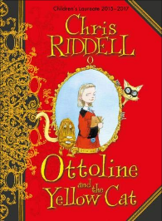  Author: Chris Riddell | 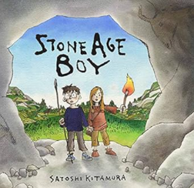  Text: Stone Age Boy  Author: Satoshi Kitamura | Text: The Iron Man  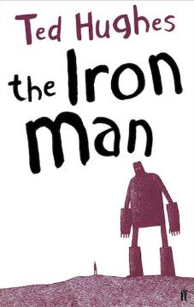  Author: Ted Hughes | 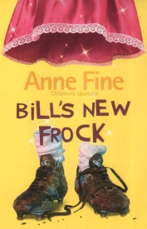  Text: Bill’s New Frock  Author: Anne Fine | 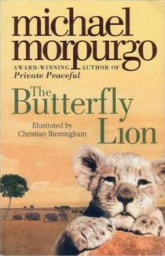  Text: Butterfly Lion  Author: Michael Morpurgo | 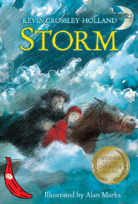  Text: Storm  Author: Kevin Crossley- Holland
READING | Non-Fiction | Information leaflet (Rivers) | Stone Age- diary entry | Letter from Antarctica | Newspaper report of Romans invading Britain | For and against argument for buying food locally | Why Were Mummies Wrapped? Miles Kelly (information text)
READING | Poetry | Water cycle poem- Helen H Moore  Water water everywhere- Jillian Harke | The dragon who ate our school | If all the world were paper- Joseph Coelho | The owl and the pussycat- Edward Lear | The magic box by Kit Wright | The spider and the fly by Mary Howitt (classic)

MATHS | Place value  Addition and subtraction |  | Addition and subtraction  Multiplication and division |  | Multiplication and division  Length and perimeter- including calculating perimeter | Fractions  Mass and Capacity-including adding and subtracting mass, capacity and volume | Fractions  Money- including adding and subtracting amounts  Time- including adding and subtracting to solve problems | Shape  Statistics  Consolidation
SCIENCE | Animals including Humans |  | Rocks |  | Plants |  | Light | Forces
HISTORY/ GEOGRAPHY |  |  | Would you prefer to live in the Stone Age, Iron Age or Bronze Age? |  |  | Why did the Romans settle in Britain? |  | What did the ancient Egyptians believe?
HISTORY/ GEOGRAPHY | What are rivers and how are they used? |  |  |  | Who lives in Antarctica? |  | Volcanoes-Why do people live near volcanoes?
ART/DT |  |  | Painting and mixed media: prehistoric painting |  |  | Drawing: growing artists |  | Craft & Design: Ancient Egyptian scrolls
ART/DT | Textiles: Cross-stitch and appliqué (Cushions) |  |  |  | Mechanical systems: Pneumatic toys |  | Cooking and nutrition: Eating seasonally
PSHE | Me and My Relationships – Cooperation and friendships |  | Valuing Differences – Recognising and respecting diversity, Being respectful and tolerant |  | Keeping Myself Safe – Managing risk, staying safe online | Rights and Responsibilities – Skills we need to develop as we grow | Being My Best – Keeping myself healthy, Celebrating and developing skills | Growing and Changing – Keeping safe, relationships
SMSC Curriculum embedded | Community  What constitutes as a positive and healthy relationship?  What being part of a community  means, and about the varied institutions that support communities locally and nationally. |  | The rule of law  To understand how and why rules and laws protect, and how other laws are made and enforced.  Who is the leader of the UK?  What do they do?  What rules do they have in place?  Democracy- is it right that women didn’t hunt? |  | Mutual Respect and Tolerance  (combating discrimination)  Explore and reflect on the stories of  creation in Judaism and Christianity. Look at religion in the home.  Compare and contrast the symbols, actions and gestures used in worship by different communities. | Democracy  What is a dictator?  Could a young pharaoh make appropriate democratic decisions?  Children begin to develop strategies to  resolve disputes and  conflict. How to solve an argument with my friends? | Individual Liberty  Making decisions- recognise when and how to ask for help, resist uncomfortable and  potentially dangerous or unhealthy situations.  Peer pressure and strategies to deal with it. | Mutual Respect and Tolerance  To work collaboratively towards shared goals, to recognise and respond  appropriately to a wider range of feelings in  others. How can we  work as a team?  Celebrating success and loss in competitive sports.
COMPUTING | Online  Safety | Networks |  | Emailing | Journey inside a computer | Creating media: Video trailers | Programming: Scratch | Data handling: Comparison cards databases
PE | River dance/  swimming,  Hockey |  | Sending and receiving/ swimming,  Basketball |  | Gymfit circuits/ swimming,  Tennis | Around the world dance/ swimming,  Cricket | Gymnastics/ swimming,  Athletics | The pyramids dance/ swimming,  Team building games/OAA
RE | What makes us human? |  | Where do our morals come from? |  | Are scriptures central to religion? | What happens if we do wrong? | Why is water symbolic? | Why is fire used ceremonially?
MUSIC | Recorders |  | Recorders |  | Three Little Birds  (Reggae) | The Dragon Song  (Music From Around The World) | Bringing Us Together  (Disco) | Reflect, Rewind & Replay  (Classical)
MFL- FRENCH | Moi |  | Time |  | Family and Friends | Look at me | Food | Shopping
SAFEGUARDING LINKS |  |  | Anti-bullying |  |  | Social dilemmas |  | Keeping Safe PANTS

