 |  | EARLSMEAD PRIMARY SCHOOL  YEAR FOUR CURRICULUM MAP
 |  | AUTUMN TERM |  |  |  |  |  |  | SPRING TERM |  |  |  | SUMMER TERM
TOPIC |  | What changed in Britain after the Anglo-Saxon invasion? |  |  | Why are rainforests important to us? |  |  | How have children’s lives changed? |  | Fairtrade: Where does our food come from? |  | Were the Vikings raiders, traders or settlers? |  | What are rivers and how are they used?
 |  | History |  |  | Geography |  |  | History |  | Geography |  | History |  | Geography
LEARNING CHALLENGE |  | What are the links between Saxon Harrow and modern day Harrow? (link to trip) |  |  | Can I identify threats to the Amazon rainforest and ways to save it? |  |  | Why did children in the past need to work, and what did these jobs entail? |  | Can I describe three advantages and three disadvantages of buying both local and imported food? |  | Were the Vikings all bad? Give three reasons for and against. |  | Can I name and describe the physical features of the River Pinn?
LAUNCH DAY |  | See, think, wonder picture: Sutton Hoo helmet |  |  | Suitcase Activity:  Children to identify the continent being studied using clues inside. |  |  | Victorian Day: Host a Victorian day in class: make gruel, draw William Morris art etc. |  | Role play: CT to complain about her weekly shop and the price of Fairtrade items and ask the class for advice on whether it is a good idea to continue – conscience alley. |  | Viking Longboats: Design, make, use and then test sail on the school pond |  | Pretend news alert!  The River Pinn is flooding. CT to show the river on a map and get the class to brainstorm what they know about rivers already.
TRIP/  ENRICHMENT |  | Headstone Manor  Museum- Saxon Harrow Workshop (Guided) |  |  | to the rainforest –  VR Workshop with PrimeVR |  |  | Tudor History Workshop – pastproductions.co.uk  Let’s Take a Trip |  | Fairtrade rep to visit: https://schools.fairtrade.org.uk/take-action/invite-a-visitor-to-speak-about-fairtrade/ |  | Viking Workshop & Viking Coins  portalstothepast.co.uk |  | River Pinn  (self-guided tour)
ENGLISH |  | Core text:  The Lost Happy Endings  Narrative: Twisted narrative  Purpose: To narrate  Persuasion: Letter  Purpose: To persuade |  |  |  | Core text:  The Whale  Narrative: Setting narrative  Purpose: To narrate  Recount: Newspaper report  Purpose: To recount |  |  | Core text:  Arthur & the Golden Rope  Narrative: Myth narrative  Purpose: To narrate  Information: Defeating a Viking monster  Purpose: To inform |  | Core Text:  Manfish  Narrative: Invention narrative  Purpose: To narrate  Recount: Jacques Cousteau biography  Purpose: To recount |  | Core text:  The Journey  Narrative: Refugee narrative  Purpose: To narrate  Recount: Diary  Purpose: To recount |  | Core text:  Leaf  Narrative: Outsider narrative  Purpose: To narrate  Information: Polar Bears  Purpose: To inform
READING | Fiction |  | 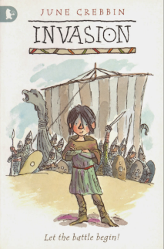  Text: Invasion  Author:  June Crebbin |  |  | Text: Christophe’s Story  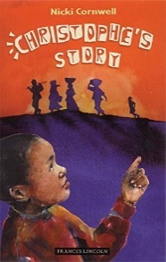  Author:  Nicki Cornwell |  |  | Text: How to Train Your Dragon  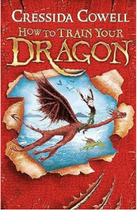  Author:  Cressida Cowell |  | 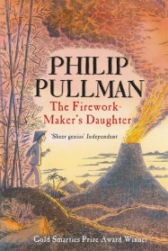  Text: The Firework Maker’s Daughter  Author:  Philip Pullman |  | Text: Pinocchio  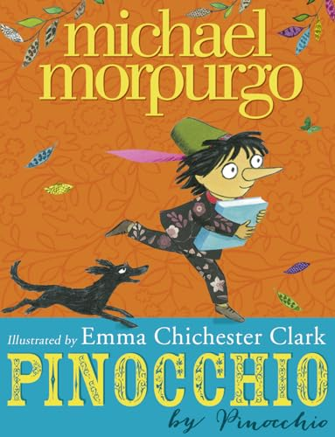  Author:  Michael Morpurgo |  | Text: Alice in Wonderland  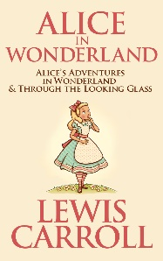  Author:  Lewis Carroll
 | Non-fiction |  | Diary Extract- An Anglo-Saxon invading Britain  Information text- Anglo-Saxons |  |  | Formal letter to the council- land use in the local area  Biography - significant black figure |  |  | Newspaper Report- The Vikings raid Lindisfarne  Instruction Guide- How to make a Viking Longship |  | Persuasive letter- written from Lila to the King  Eyewitness account- of Pompeii |  | Recount - Inside a Victorian Workhouse  Magazine article - Lord Shaftesbury’s reaction to child labour |  | Monologue- Alice  Explanation text about the rainforest.
 | Poetry |  | The Wrath of the Awakened Saxon- Rudyard Kipling* |  |  | The Sound Collector- Roger McGough |  |  | Vinnie’s Veggies |  | Firework Night- Enid Blyton |  | Edgar Allen Poe’s ‘The Raven’ 1845 |  | Rainforest- Angela Mcallister
MATHS |  | Place value  Addition and  subtraction |  |  |  | Addition and subtraction  Multiplication and division |  |  | Multiplication and division  Length and perimeter- calculating perimeters of shapes |  | Fractions  Decimals |  | Decimals  Money- including calculating and solving problems with money  Time |  | Shape  Statistics  Position and direction
SCIENCE |  | Sound |  |  |  | Animals, including humans |  |  | States of matter – 8 lessons  Classification – lesson 1 & 4 |  |  |  | Electricity |  | Living things and their habitats  (human impact)
HISTORY/  GEOGRAPHY |  | How hard was it to invade and settle in Britain? |  |  |  |  |  |  | How have children’s lives changed? |  |  |  | Were the Vikings raiders, traders or settlers?
 |  |  |  |  |  | Are all settlements the same? |  |  |  |  | Fairtrade-Where does our food come from? |  |  |  | Why are rainforests important to us?
ART/DT |  |  |  |  |  | Sculpture and 3D: Abstract Shape |  |  |  |  | Painting and mixed media: light and dark |  | Drawing: power prints
 |  | Structure: Pavilions |  |  |  |  |  |  | Digital world: Mindful moments timer |  |  |  |  |  | Electrical systems: Torches
PSHE |  | Me and My  Relationships – Recognising feelings, bullying, assertive skills |  |  |  | Valuing Differences – Recognising and celebrating differences, Understanding and challenging stereotypes |  |  | Rights and  Responsibilities – Decisions about money and media influence |  | Keeping Myself  Safe – Managing risk, Understanding drug use (cigarettes and alcohol) |  | Being My Best – Having choices and making healthy decisions, Taking care of the environment |  | Growing and  Changing – Managing difficult feelings, puberty, relationships
SMSC  Curriculum embedded |  | Rule of Law Individual Liberty |  |  |  | Safety & Wellbeing  Personal Challenge |  |  | Healthy Body  Healthy Mind |  | Mutual Respect Tolerance |  | Democracy  Individual Liberty |  | Fair Trade  Mutual Respect  Environment
COMPUTING |  | Online Safety |  | Collaborative learning |  |  | Website design |  | Skills showcase: HTML |  | Programming 1: Further coding with Scratch |  | Programming 2: Computational thinking |  | Data handling: Investigating weather
PE |  | Anglo Saxons dance / swimming,  Hockey |  |  |  | Dance / swimming,  Basketball |  |  | Tudor dance/ swimming,  Tennis |  | Mighty movers/ swimming,  Cricket |  | Sending and receiving / swimming,  Athletics |  | Gymnastics/ swimming,  Team games/ OAA
RE |  | Are all religions equal? |  |  |  | What makes some texts sacred? |  |  | Just how important are our beliefs? |  | Who was Jesus? |  | Why is the Bible the best-selling book of all time? |  | Does the language of scripture matter?
MUSIC |  | Mamma Mia  (Pop) |  |  |  | Glockenspiel Stage 2  (Mixed Styles) |  |  | Lean On Me  (Gospel) |  | Stop!  (Grime) |  | Blackbird  (The Beatles/ Pop) |  | Reflect, Rewind & Replay  (Classical)
MFL- FRENCH |  | All about me |  |  |  | All around Town |  |  | Going Shopping |  | What’s the Time? |  | My school |  | Holidays and Hobbies
SAFEGUARDING LINKS |  | Anti-bullying |  |  |  | Keeping safe around fireworks |  |  | The effects of alcohol |  | Health and safety in the kitchen |  | Keeping Safe PANTS |  | Water safety

