
EARLSMEAD PRIMARY SCHOOL
YEAR SIX CURRICULUM MAP
 |  | AUTUMN TERM |  |  |  | SPRING TERM |  | SUMMER TERM
TOPIC |  | What was the impact of World War 2 on the people of Britain? |  | Why does population change? |  | How did the Maya civilisation compare to the Anglo-Saxons? | Where does our energy come from? | Who should feature on the £10.00 banknote? | Can I carry out an independent fieldwork enquiry in Harrow?
 |  | History |  | Geography |  | History | Geography | History | Geography
LEARNING CHALLENGE |  | What role did RAF Northolt play in World War II? |  | Can I identify ways that the population can positively and negatively impact the environment? |  | What are the key differences between Maya and Anglo-Saxon buildings? | Can I identify types of renewable and non-renewable energy sources, and explain the importance of its development? | What does it mean to be historically significant? | Can I identify the impact and risks a new school car park will have on traffic flow?
LAUNCH DAY |  | CT to show an old backpack which has been ‘loaned’ to the school from a museum. Inside are various items belonging to a soldier e.g. rations an empty can, socks etc. |  | CT to read a letter from a grandparent (air mail). CT to discuss contents of the letter and ask why they think someone would choose to relocate so far away. Chn to debate. |  | A ‘time capsule’ is found with various Anglo-saxon items – including a stale honey and oat cake. Link to a time capsule ‘recently found’ in South America which had cacao beans inside. Chn to spend unit investigating who could’ve buried these. | Role play - CT to discuss the house they are building/renovating to another member of staff. CT to discuss cutting costs and not adding solar panels to the property. CT to open up discussion to the class which will lead to the pupils completing KWL grid on renewable and non-renewable energy sources. | CT to hide prop money in the class for children to find. Once children realise the money is fake, ask them what features are on a real note. Discuss choice of individual on £10 – i.e. the queen. Explain that as of mid-2024, the king will be on the notes. Chn to create conscience alley to debate whether or not the bank notes should change. | Role play: CT and AS to argue (1 for and 1 against) about flyer they received which says there will be a new school car park next year. CT ask chn to brainstorm their initial thoughts to prepare to support or petition this new idea. Conscience Alley at the end with one pupil role playing Ms Graham
POSSIBLE TRIP/  ENRICHMENT |  | RAF Hendon |  |  |  | Ancient Mayan Workshop- Pastproductions.co.uk |  | Bank of England (presentation and museum) | Local Walk:  Explore data collection in the local area (sound recordings, questionnaires, photographs).
ENGLISH |  | Core text:  Rose Blanche by Christophe Gallaz and Roberto Innocenti, and Anne Frank by Josephine Poole  Recount: Diary  Purpose: To recount  Recount: Bravery speech award  Purpose: To recount |  | Core text:  A Story Like the Wind  Narrative: Flashback narrative  Purpose: To narrate  Recount: Newspaper report  Purpose: To recount |  | Core text:  The Ways of the World by Smriti Prasadam  - Narrative: Documentary narrative  Purpose: To narrate  - Discussion: Balanced argument  Purpose: To discuss  - Narrative: Hunted narrative  Purpose: To narrate | Core text:  Shackleton’s Journey  Narrative: Endurance narrative  Purpose: To narrate  Recount: Magazine article  Purpose: To recount & inform (hybrid) | Core text:  Hansel and Gretel  Narrative: Dual narrative  Purpose: To narrate  Persuasion: Letter  Purpose: To persuade | Core text:  On the Origin of Species  Narrative: Discovery narrative  Purpose: To narrate  Explanation: Adaptation  Purpose: To explain
READING | Fiction | 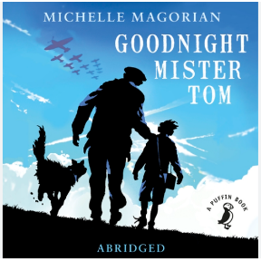  Text: Goodnight Mr Tom  Author:  Michelle Magorian |  | 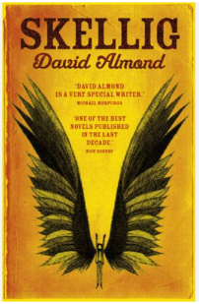  Text: Skellig  Author: David Almond |  | 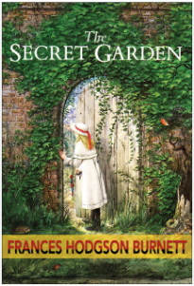  Text: The Secret Garden  Author:  Frances Hodgson Burnett | 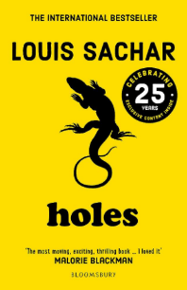  Text: Holes  Author:  Louis Sachar | 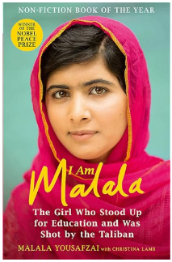  Text: I Am Malala  Author:  Malala | 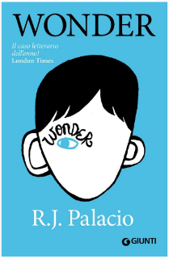  Text: Wonder  Author:  R.J. Palacio
READING | Non-fiction | Historical account  Britain in the Blitz.  Diary extract – Anne Frank |  | Biography about Greta Thunberg  Explanation text about climate change |  | Formal letter  Newspaper report about discovery of Anglo-Saxon tomb in Sutton Hoo. | Brochure about the Alps.  Instruction guide for first time skiers. | Monologue from Barbie 2023 movie*  *Fiction |  | Petition to increase SEND funding for schools.  Email thread between an estate agent and a client - informal and formal.
READING | Poetry | Spinner by Gwen Dunn/ Can you see the wind? |  | The Jabberwocky by Lewis Carroll* |  | Highwayman by Alfred Noyes* | Small Incident in Library by David Sutton | And Still I Rise by Maya Angelou |  | If By Rudyard Kipling*
MATHS |  | Place value  Addition and subtraction  Multiplication and division |  | Fractions- including adding, subtracting, multiplying and dividing fractions  Converting units- including calculating with metric measures |  | Ratio  Algebra  Decimals- including adding, subtracting, multiplying and dividing | Fractions, decimals and percentages- including adding, subtracting, multiplying and dividing  Area, perimeter and volume  Statistics | Shape  Position and direction  SATS | Themed projects, consolidation and problem solving
SCIENCE |  | Living things and their habitats |  | Electricity |  | Animals, including humans (circulation) | Animals, including humans (body health) | Light | Evolution and inheritance
HISTORY/  GEOGRAPHY |  | What was the impact of world war 2 on the people of Britain? |  |  |  | How did the Maya civilisation compare to the Anglo-Saxons? |  | What does it mean to be historically significant?
 |  |  |  | Where does our energy come from? |  |  | What is life like in the Alps? |  | Why does population change?
ART/DT |  | Drawing: Make my voice heard (link to propaganda) |  |  |  | Painting and mixed media: artist study |  | Sculpture and 3D: Making memories
 |  |  |  | Electrical systems: steady hand game |  |  | Digital world: navigating the world as a trekker |  | Cooking and nutrition: Come dine with me
PSHE |  | Me and My Relationships – Cooperation, assertiveness, safe and unsafe touches |  | Valuing Differences – Recognising and reflecting on prejudice-based bullying. |  | Keeping Myself Safe – Staying safe online, Drugs and the law | Rights and Responsibilities – Earning and saving money, Understanding media bias, Communities and the environment | Being My Best – Managing risk, aspirations and goals | Growing and Changing – Self-esteem, keeping safe, body image
SMSC Curriculum embedded |  | Mutual Respect and Tolerance- Children to appreciate the range of national, regional, religious and ethnic identities in UK and understand what being part of a commutinty means. |  | Health and Wellbeing  Children to manage growth and change as normal parts of growing up. Understand how body and mind grow and mature |  | Mutual Respect and Tolerance- Bullying  Children to recognise bullying and abuse in all its forms (including prejudice) | The Rule Of Law  Understand and respect the civil and criminal law in England. How is the rule of law related to human rights? | Mutual Respect and Tolerance – Combatting Discrimination. Children to consider lives of people living in other places with different values and customs | Individual Liberty  Identify strategies for keeping safe online; the importance of protecting personal information and distribution of images
COMPUTING |  | Online safety | The history of computers |  | Exploring AI | Data handling 1 & 2 |  | Programming: Intro to Python | Skills showcase: Inventing a product
PE |  | Gymnastics- Parkour,  Tennis |  | Indoor athletics,  Netball |  | Gymnastics- Rolling and static positions,  Football | Boccia/ kurling,  Rounders | Volleyball,  Athletics | Badminton,  Orienteering/ team building games
RE |  | Why does religion look different around the world? (part 1) |  | Why does religion look different around the world? (part 2) |  | Why is it better to be there in person? | Why is there suffering?  (part 1) | Why is there suffering?  (part 2) | What place does religion have in our world today?
MUSIC |  | Happy  (Pop/ Motown) |  | Classroom Jazz  (Jazz, Latin and Blues) |  | A New Year Carol  (Classical,Urban and Gospel) | You’ve Got A Friend In Me  (70’s Pop Ballad) | Music And Me  (Create your own music inspired by your identity) | Reflect, Rewind & Replay  (Western Classical and The History Of Music)
MFL- FRENCH |  | All about me |  | All in a Day |  | Let's Visit a French Town | Let’s Go Shopping | This is France! | Our Precious Planet
SAFEGUARDING LINKS |  | Conflict resolution/  Discrimination |  | Electrical safety |  | Anti-bullying | Effects of drugs | Managing feelings | Keeping Safe  PANTS  Navigating the Underground

