Earlsmead
Primary School

Teacher Induction Policy



Written by | N Peshawaria
LGB Approved | October 2026
BOT Ratified | October 2026
Date of Review | September 2028

v

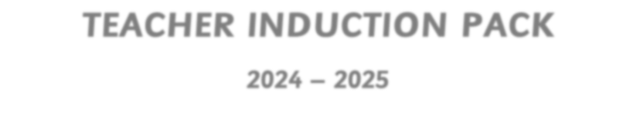




202
6

–

202
8

MISSION STATEMENT

At Earlsmead Primary School, our mission is to empower every child through Head, Heart, and Hands. We cultivate curious minds (Head), nurture compassionate spirits (Heart), and develop the practical skills (Hands) needed to thrive in an ever-changing world.

VISION
Everyone achieving their full potential.

OUR MOTTO
Head, Heart and Hands
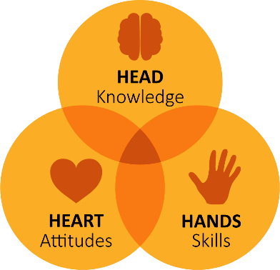
 | OUR VALUES
Head: | 1. Curiosity 2. Achievement
Heart: | 3. Integrity 4. Care
Hands: | 5. Collaboration 6. Creativity

Dear Colleague,

Page 2 Welcome
Page 3 Staff Induction Sheet
Page 5 Vision
Page 6 Key information Page 7 Safeguarding
Page 8 Wellbeing
Welcome to Earlsmead Primary School!
We hope you enjoy your time as part of our hardworking and dedicated team. We aim to set every new staff member up for success. This induction programme is one way that we can help to make that happen.
Welcome

letter

Contents

We recognise that our pupils will achieve most from well-informed, highly motivated staff. New staff will be supported during their induction period. We aim to complete induction promptly but thoroughly.
This induction pack contains material which will support you to learn more about our school and how we do things. You will then be able to contribute to the maintenance of high standards of performance in your job and to the general ethos of the school.

At the beginning of your induction programme, please ensure that you have familiarised yourself with the following:
- Your Job Description – you should have received a copy of your Job Description prior to your appointment.
- The Staff Code of Conduct – you should have received a copy of this prior to your appointment.
- School Policies – Saved in the Shared Area (T Drive) under ‘Policies’
- The School Website – this includes lots of information on our policies, values, organisation, curriculum, staff etc.
- Fire Safety exit points and assembly points – KS2 Playground.

Ms Graham Headteacher
Name:
Role:
Start Date of Employment:
Induction Lead: N. Peshawaria

By the end of the first week
You should have been shown/told about:
Code of Conduct
Safeguarding Training including Child
Protection & E-Safety Policies - CPOMS
School aims and values
Mission statement
SEND Policy
Behaviour Policy
Bromcom - Registers and Assessment
Health and Safety Policy and Presentation
Intimate Care Policy including Reducing the Risk of Allegation
Behaviour systems (Class Dojo)
Lunchtime procedures
Keeping fire doors and exits clear of obstruction
Self-certification of sickness
Request for Leave of Absence Form
Accident and illness procedures
Accident forms
Information on curriculum expectations
By the end of the first day
You should have been shown/told about:
Timetable and class lists
Where to put your coat and bag/personal belongings
Toilets – staff and pupils
First Aiders – who they are
Location of the medical room (Welfare)
Who manages whom - Staff schemata
Fire drills and procedures
Security of the building, signing in and out
Duties and Rotas
Staff briefings and meetings
Car parking
Staff lunch
Use of phones/private calls
IT log in and email details

Staff

Induction

Sheet


Between

weeks

one to

six

Lesson plan formats
Pupil assessment - Insight
Annual reviews
End of year reports
Curriculum schemes
End of term assessments (core & foundation)
Achievement assemblies
School Improvement Plan
School Development Plan
Classroom book corners
Inclusion folders
School library
Stock ordering
Marking and Feedback Policy
Electrical safety
Supervision of pupils – activity duties
Using the: Photocopier Laminator
Guillotine
Shredder
Risograph
Requesting IT support
Risk Assessments for all activities
School trip procedures
Homework procedures
Diaries – school office
Location of curriculum resources
Annotating pupils’ work
Interactive whiteboard/ screen
Teacher:

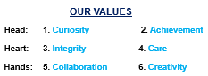


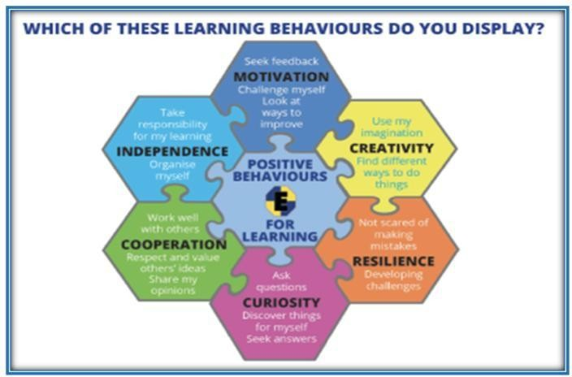
Key Information
Health and Safety | Our Staffroom | Confidentiality
All members of staff are responsible for the health and safety of everyone in the school community.  Please report any potential safety hazard or risk to the Site Team.  Any faults that need to be looked at can be written on the whiteboard opposite the site team cupboard.  Please read the Health and Safety Policy and presentation, which outline your roles and responsibilities towards Health and Safety.  First aiders – displayed on the wall of each classroom. | • Everyone is welcome.  • There are no ‘special’ chairs.  • Please put your washing up in the dishwasher. • Please take your turn to unload the dishwasher once full – a rota is on the staffroom board.  • Please keep kitchen areas tidy at all times.  • Please throw away unwanted food.  • Please keep the staffroom tidy. All staff need to be aware of confidentiality issues when using the staffroom.  No staff should carry hot drinks out of the staffroom without a lid. | All adults working in a school, on a paid or voluntary basis, are in a privileged position regarding what they may say or hear.  It is vital that, except where Child Protection Issues are concerned, confidentiality is respected in all cases.  It is NOT appropriate to:  • Discuss a child’s progress or behaviour with anyone other than that child’s parents or guardians, or relevant member of staff.  • Discuss a child’s progress or behaviour with a parent ‘out of school’ – this includes on the internet/social network.  • Discuss a child or family in front of others

Key Information
Professionalism | Breaks | Confidentiality
• Be punctual and maintain good attendance. Follow the attendance procedure if you will not be in.  • Dress appropriately and present a professional image.  • Do not be tempted to be ‘friends’ with parents and pupils on any social networking sites.  • All staff are expected to act in a professional manner at ALL times.  • For any complaints, please refer to the school.  • Whistleblowing Policy on the school website.  • Refer to our Staff Code of Conduct and other relevant policies. | • We do not deny toilet break requests. Children should be given a toilet break pass.  • Children are encouraged to take ‘brain breaks’ if they need them.  • Each class has access to drinking water.  • All children are allowed to bring a named water bottle to drink at appropriate times.  • Fruit – free fruit for children up to Year 2 – located next to welfare. | • Every class reads (Drop Everything and Read) at 3pm.  Children should already have tidied and packed their bags at this time.  • Send letters, books, etc. home.  • Please ensure that the children are met by a known adult. All agreed names should be on the yellow dismissal slip.  • Dismissal register is to be completed each day with details of who collected each child.  • Staff to be aware of who is attending clubs.

Safeguarding
DfE’s statutory guidance Keeping children safe in education (publishing.service.gov.uk) is updated every year. It states that safeguarding and promoting the welfare of children is everyone’s responsibility and that school staff are particularly important as they are in a position to identify concerns early, provide help for children, and prevent concerns from escalating.
It is important to familiarise yourself with part one of this guidance, as well as our school’s safeguarding policy and practice at the start of the year – and to ask questions about anything you are unsure of.

If you have a concern about a child’s welfare, you should follow the school’s referral processes set out in school’s safeguarding policy and procedures. If need be, you are expected to support social workers and other agencies following any referral.

Every school has a designated safeguarding lead who is a member of the school’s leadership team and provides support to staff to carry out their safeguarding duties and liaises closely with other services such as children’s social care.
The school’s Designated Safeguarding Lead is:
Jackie Stangroom

The Deputy Designated Safeguarding Lead is:
Catherine Fennell. Sarah Redmond is also Level 3 Trained.
The Designated Safeguarding Lead will have shared the school’s safeguarding policy, staff code of conduct and other relevant procedures and documents with you as part of your induction.

We use CPOMS for Safeguarding.

If you think a child or young person is in need because they are suffering or likely to suffer significant harm:
- Make a note of what you have seen or been told: don’t make assumptions – keep an open mind

- Don’t ask any leading questions and don’t cross-examine the child. Only ask simple and open questions – Who? What? Where? When? etc.

- Don’t physically examine the child (other than in an emergency when no first aider is available).

- NEVER promise to keep “secrets”. Explain that you can listen to them but make it clear that if you perceive that they are in any danger of harm then you will have to seek advice because you have a duty to protect children and young people. Reassure them that they can be helped and kept safe.

- Maintain confidentiality for the child or young person. Be discreet – do or say nothing that may place the child or yourself at risk.

- It is normally the role of the Designated Safeguarding Lead to ring home or contact relevant teams in the Local Authority.

- Act quickly and share the information with your Designated and/or Deputy Designated Safeguarding Lead.

All staff are responsible for safeguarding children.
- If the disclosure or your concern relates to a member of staff, this must as soon as possible be shared with the Headteacher or the Designated Safeguarding Lead if the Headteacher is not available and nothing should be said to the colleague involved. It must be shared with the Chair of Governors if it relates to the Headteacher.

Tips and strategies for time and workload management
Strategies that might work for you include:
Creating clear boundaries between work and home. Try not to let work spill over into your personal life. If you need to bring work home, designate a separate area for work and stick to it, you’ll find it much easier to then close the door on work.

Planning your work. Find a way that suits you, some people use a planner or make a ‘realistic’ to do list. (At the end of each day, go over your list/ planner and write up one for the next day, when your thoughts are down on paper, you’ll find it easier to not think about work.

Managing your working hours.
You’ll have times when you need to work longer to meet deadlines but try to make this the exception not the norm. Long hours mean you may be working harder, but not better – they’ll quickly take their toll on your concentration, productiveness and health and your ability to implement the ‘cycle of care’ effectively.
Working smart not long. This involves tight prioritisation and allowing yourself a certain amount of time per task. Try not to get caught up in less productive activities.
Do you, for example, check your e-mails only at specific points in the day?
Is your e-mail alert turned off?

When asked or given the opportunity, to do an optional additional/ different activity, give yourself time to think about it and how you would manage it before saying yes or no?

Wellbeing. At the Head’s discretion, PPA and management time may be taken off site. We are also have staff well-being days where staff may book two half days or one whole day for their wellbeing. Speak to your Phase Leader if you would like to more about these systems.
Earlsmead WhatsApp. Most of our staff have elected to join our school WhatsApp group. This helps us communicate messages quickly with the whole group e.g. if there is a snow day, change of schedule or we are organising a social event. We do not share any children’s photos or confidential information within this group.
You do not have to be part of this group. You can ‘mute’ notifications from the group at any time.
Accepting help and asking for help. Your induction tutor and mentor will meet with you regularly and will be a valuable source of advice, resources and assistance, as will your colleagues and fellow ECTs. There are also a range of external organisations who support teachers including trade unions and the charity Education Support Partnership.
Earslmead offers free, confidential counselling through our Employee Assistance Programme (EAP) on Ph: 08000 856 148
Good versus fabulous. Sometimes, if you’re busy, you need to explicitly tell yourself that what you’ve done may not be perfect, but it is good enough.
Using the time on your commute home to wind down from work. Read a book, catch up with a podcast or listen to your music - set aside some time to yourself. Maybe try cycling part of your journey or getting off a stop early to take a shortcut through a park or quiet streets. These little actions can really help you to switch off and regain energy.
Having a life outside work and school. Have interests and a life outside of the job.

